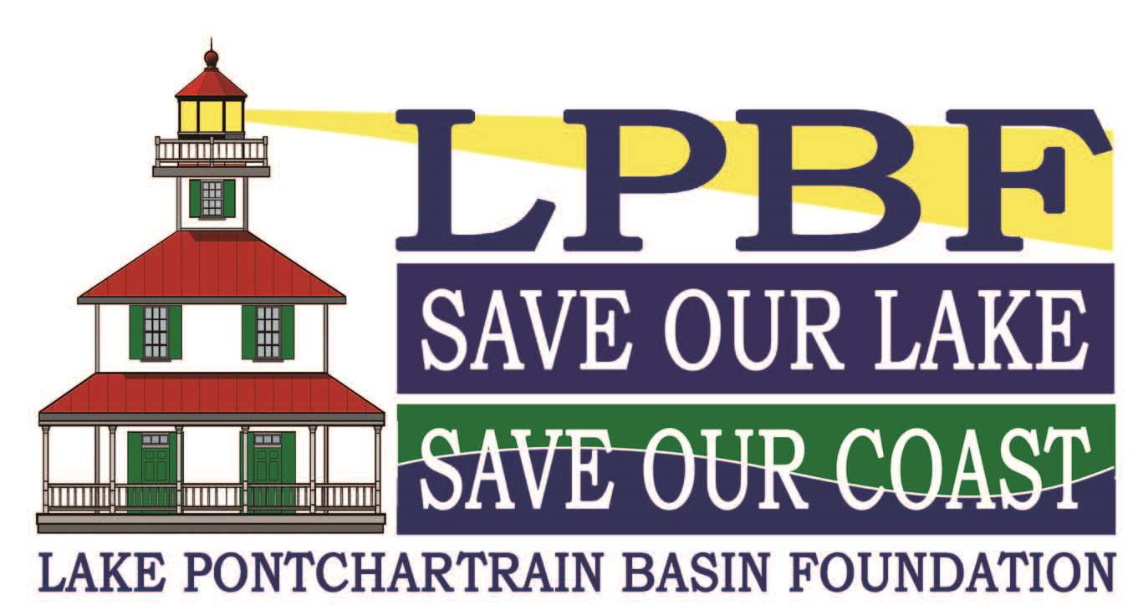

Lake Pontchartrain Basin Foundation Photo Release Form

I, _____________________________________, hereby grant permission to Lake Pontchartrain Basin Foundation and the New Canal Lighthouse, its representatives, and employees to take photographs of myself in connection with the provided programs. I authorize LPBF, its assigns and transferees to copyright, use and publish the same in print and/or electronically. I agree that LPBF may use such photographs of me and for any lawful purpose, including for example such purposes as publicity, illustration, advertising, and web content. I hereby further release, indemnify, and hold harmless Lake Pontchartrain Basin Foundation and New Canal Lighthouse, their directors, employees, and insurers from any and all claims and/or damages on behalf of myself arising from the publication of my photograph, videotape and/or film on LPBF’s website or publications.

I have read and understand the above:

______________________________ ________________________
Signature Date
______________________________
Print

